Building a Simple Focus Stacking System
Ted Kinsman
August 2025
Rochester Institute of Technology
Rochester, NY

Each year my photographic instrumentation students build very simple focus stacking systems. After several years, I decided to build a more complex system that can move a stepping motor stage to a specific position and collect number of images that are in turn exported to a focus stacking program that will combine the images into a single image.
I am always surprised to discover that many photographers do not know what focus stacking is and how it is used. In the simplest from as applied to macro photography, focus stacking is the art of collecting an image, moving the subject a fraction of the depth of field, and taking an other image until the region of interest is covered. Each image is collected at the highest resolution that the lens has the ability to collect. The resulting stack of images is combined into one image using special tools in programs like Photoshop, Helicon Focus or Zerene Stacker. My favorite program for this application is Helicon stacker which is fine tuned for this application.
There are focus stacking systems on the market, but each of these has limitations, weather the stability of the rail over long distances, the price tag, or there are desired features that are missing. When you build your own system, you can design it any way you want.
My system is designed around the Canon MP-E 65mm f/2.8 1-5x Macro Photo Lens that covers a magnification of 1 to 5 x. The lens is very well documented by the manufacture, and this information is provided in the lens user guide.
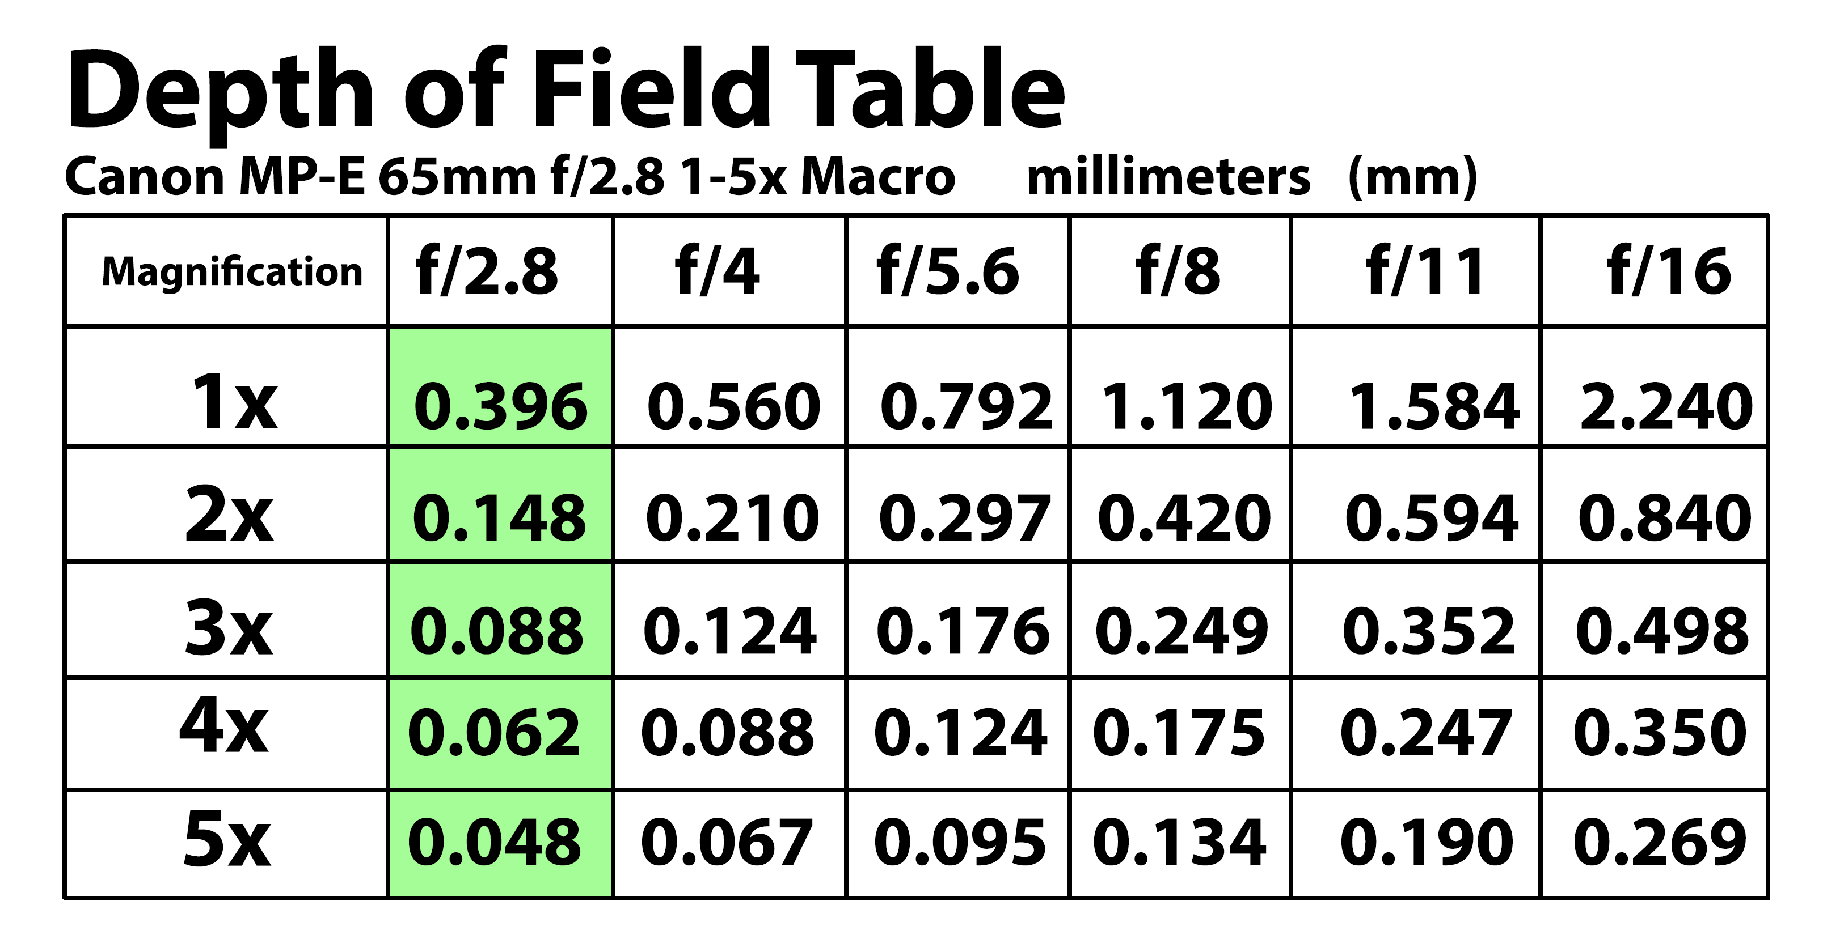
This data is from the Canon lens manual and has been reformatted in photoshop. The Green zones are the areas of highest resolution, and the rest of the chart is not used for high resolution focus stacking. A photographer can go to a higher f number to get a larger depth of field, but this will cause a loss of resolution. There are times when a photographer moves to a higher f number to decrease the number of required images to cover an area, and thus decrease photography time and decrease the use of computer memory.
To set the depth of a focus stacking stage – a general rule of thumb is to take the Depth of Field (DOF) and cut the distance in half. One example for the 2X setting at f/2.8 would be to have the focus stacking rail move a distance of 0.074 mm.
Focus stacking can yield excellent images with the right subjects (fuzzy subjects with lots of overlapping hairs yield confusing images) while smooth objects like insect eyes easily combine in the software to make good images.
The use of focus stacking is often a balance between time and final image use. It is easy to spend way too much time on an image that will only be downsized to the size of stamp.

This project stats with obtaining a good positioning rail. I would recommend buying a used rail, and recently it came to my attention that auto pipet machines have a very high-quality rain in them and two very high-quality stepping motors. These items are flooding ebay at the moment since the auto pipet machines are updated every year or so. These directions are built around an Adafruit 12volt stepping motor which is easily available and a good stepping motor to learn on.
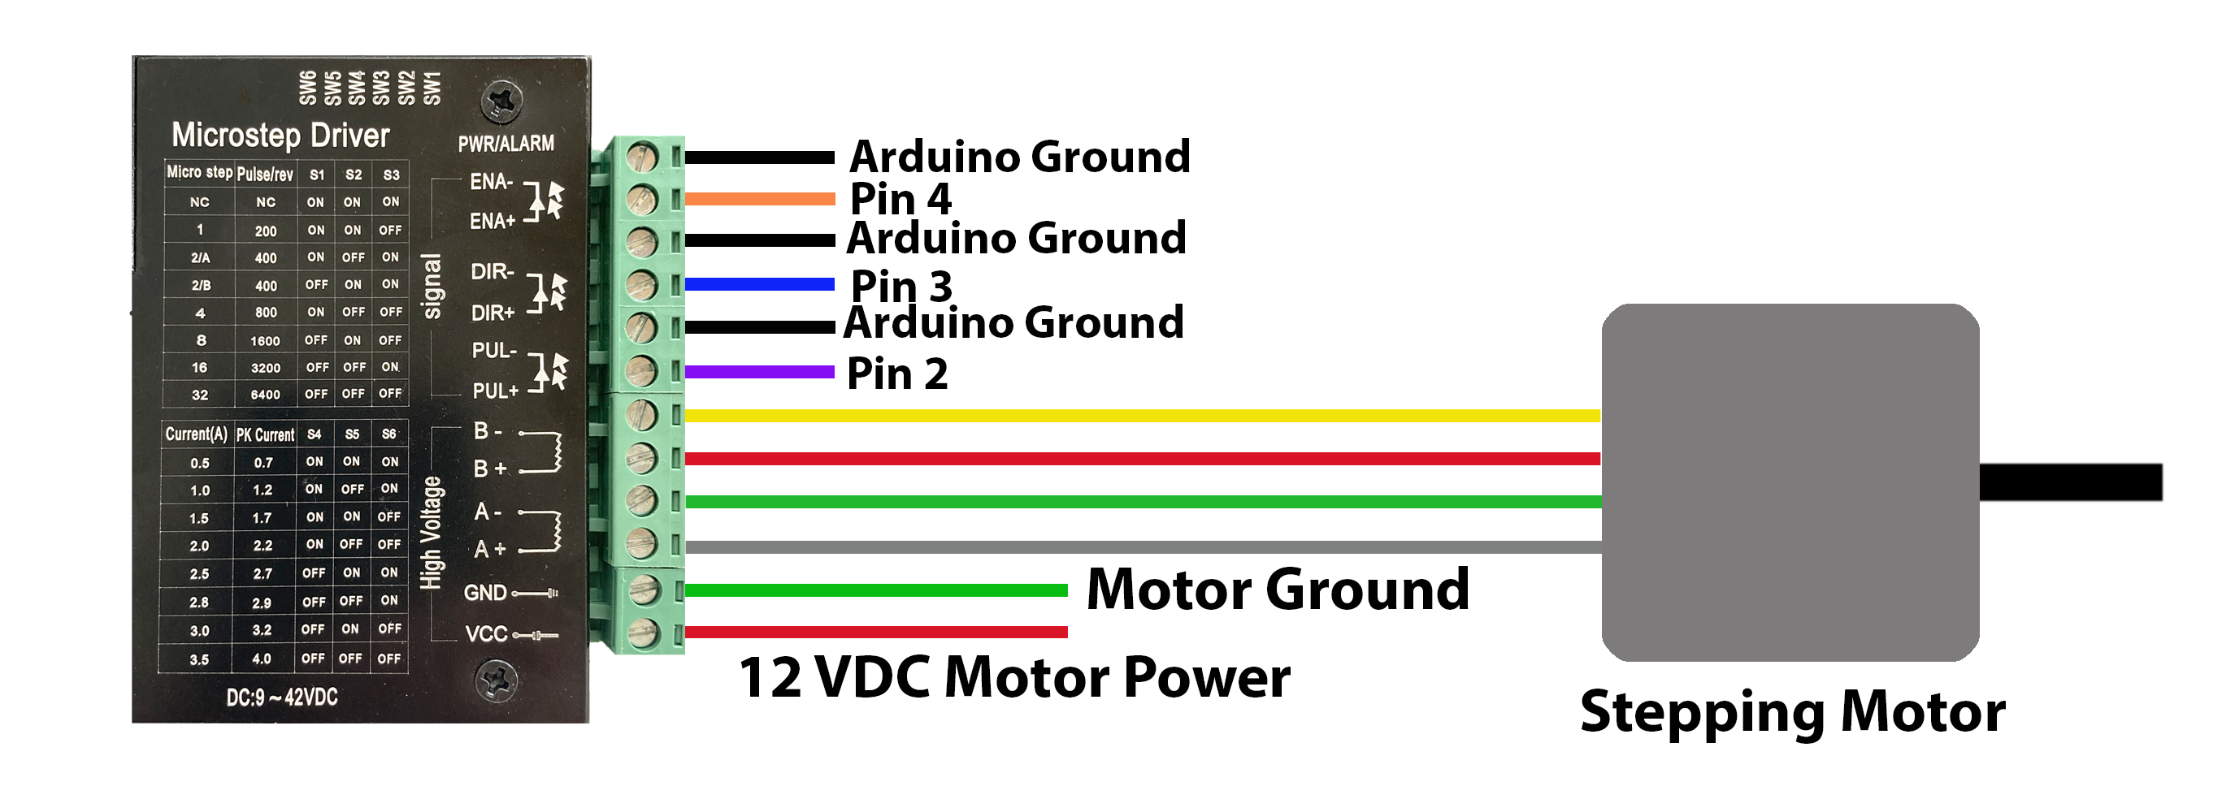
To control the stepping motor a TB6600/TB6660 stepper driver using the AccelStepper library. This controller can operate a number of different stepping motor configurations and is very versatile. The stepping motor controller is very reasonably priced.
The connection circuits are fairly standard. The push buttons to control forward, reverse, and start are standard Arduino buttons.
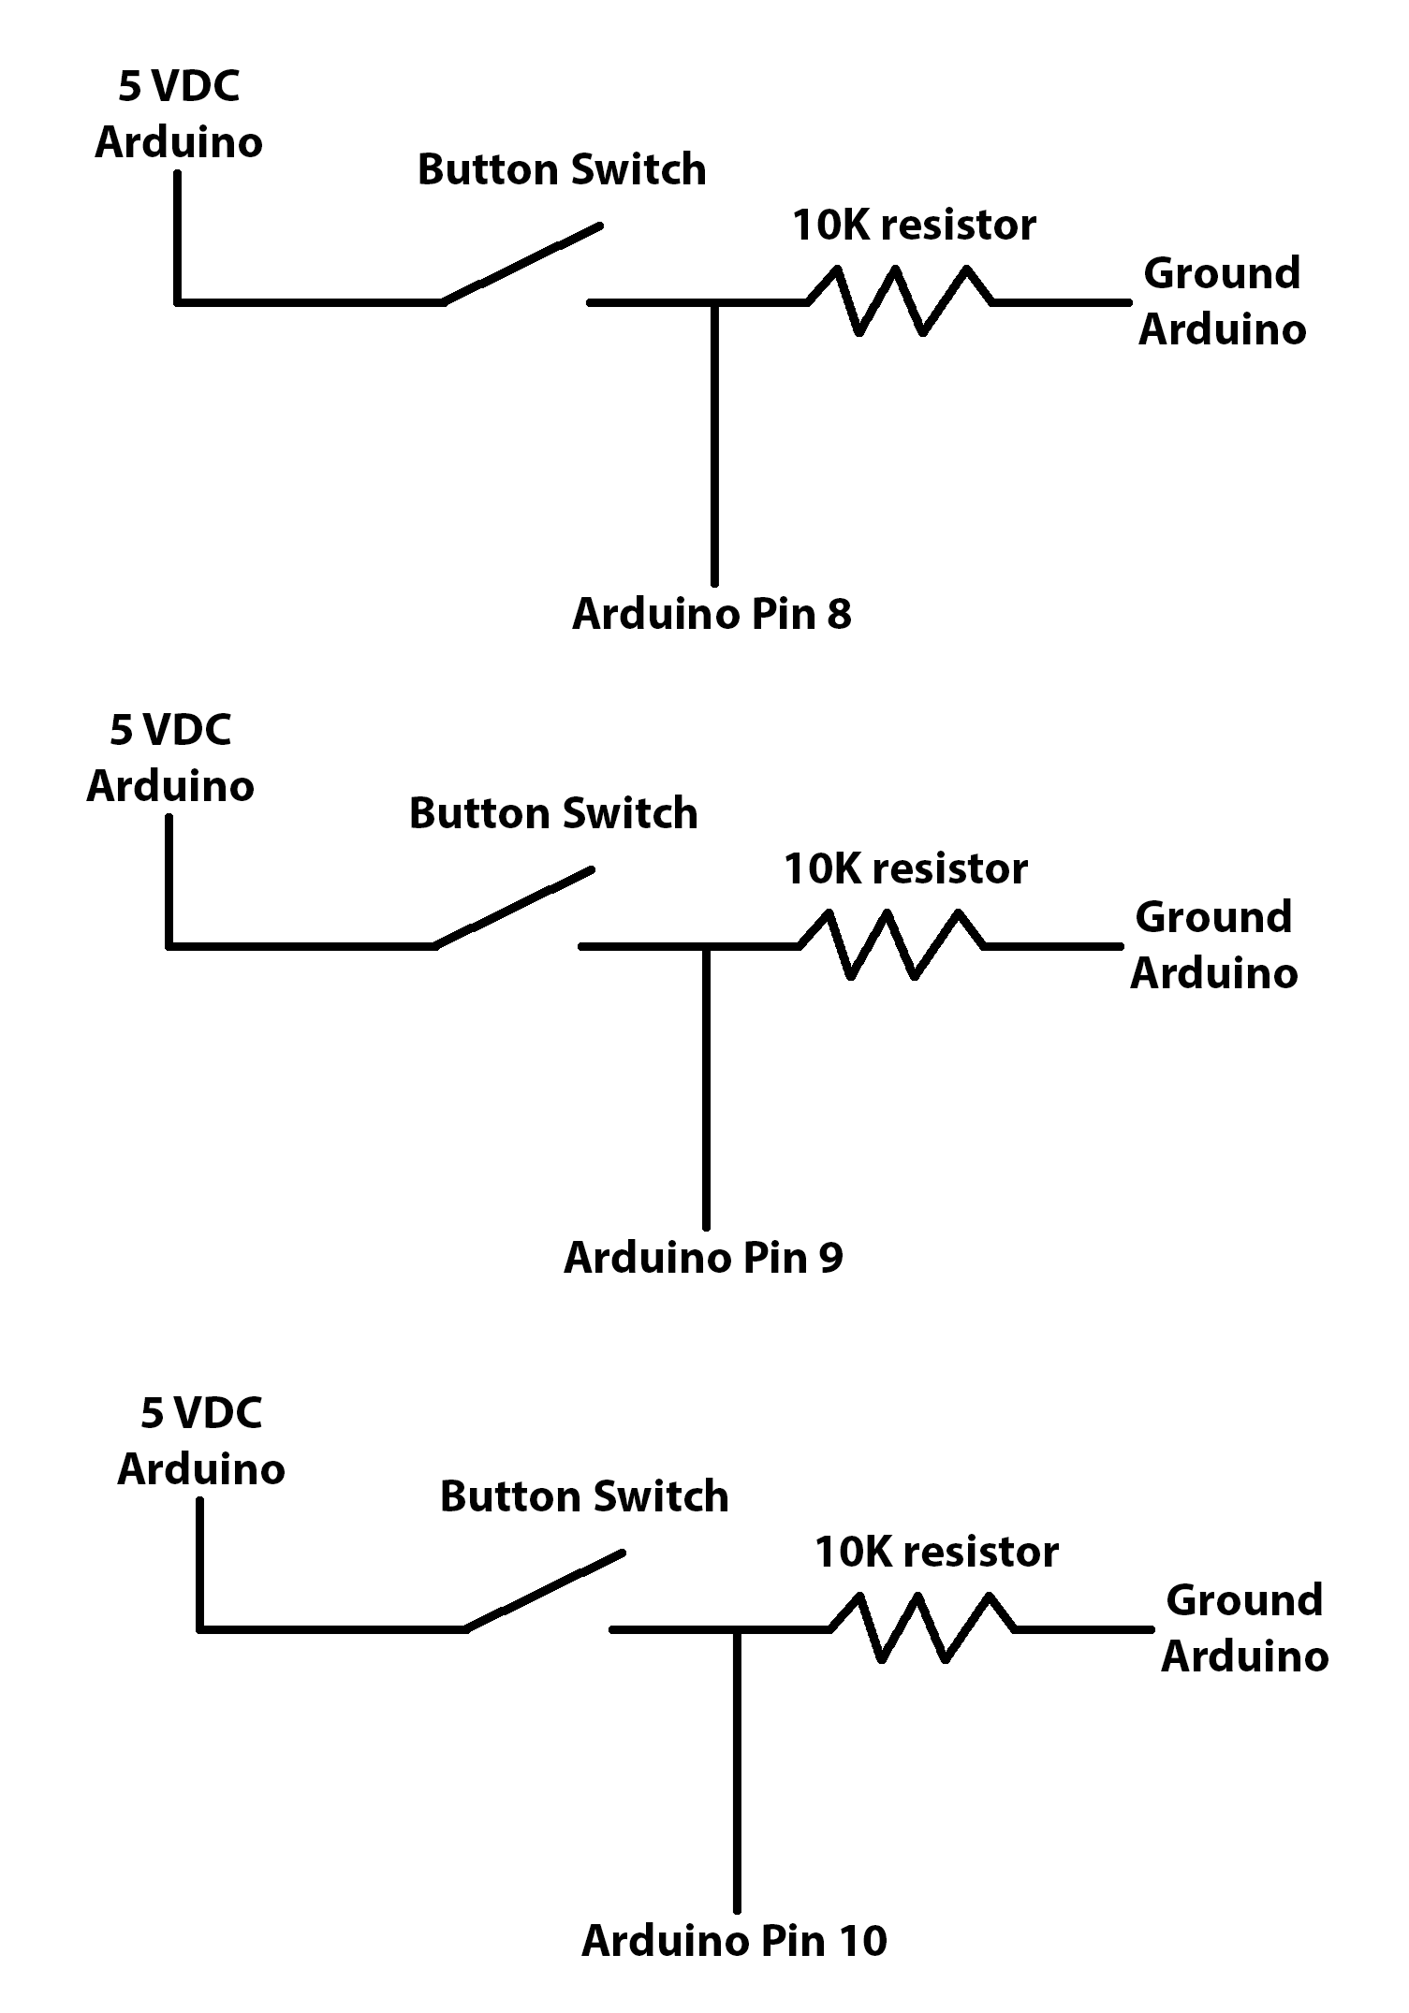
Each of the buttons use a 10kilo ohm pull down resistor, since the code is triggered by a pin going high to 5 volts.
The camera triggering uses two reed solenoids.
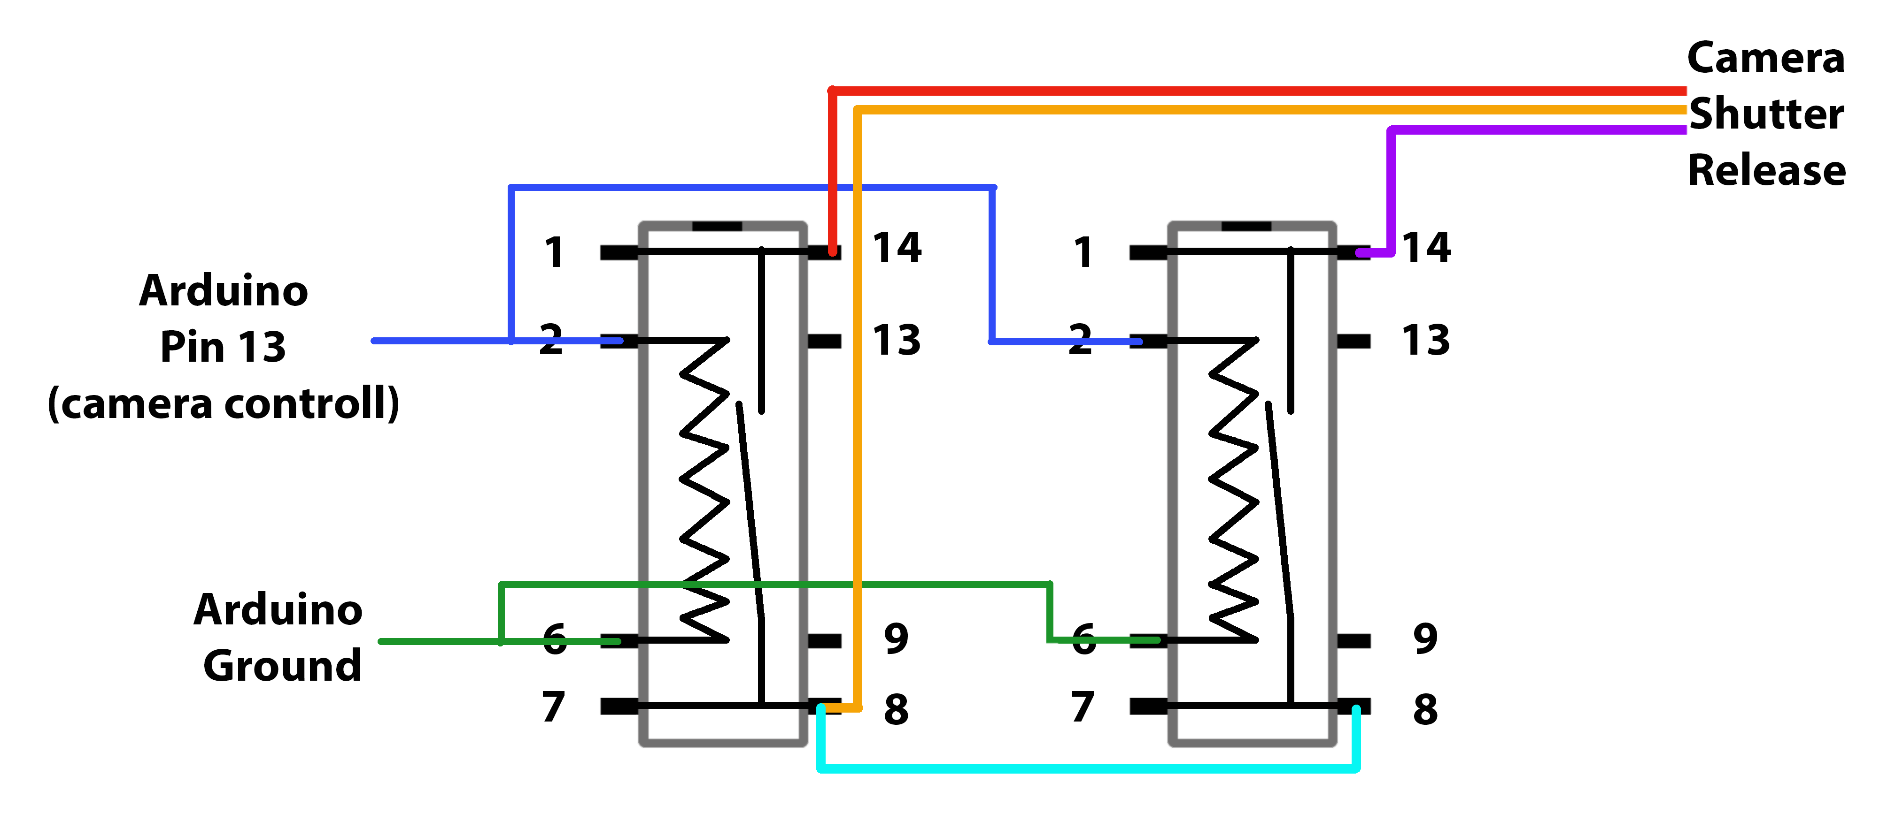
The reed solenoinds are not super-fast, but work well at creating total electrical isolation between an expensive camera and the Arduino circuit. The majority of cameras look for a focus trigger and a shutter trigger, but if all three control wires are connected around the same time the camera will trigger. This circuit works well for standard Canon, Nikon, and Sony cameras.
Get set some visual feed back the circuit is doing something I use several LEDs.
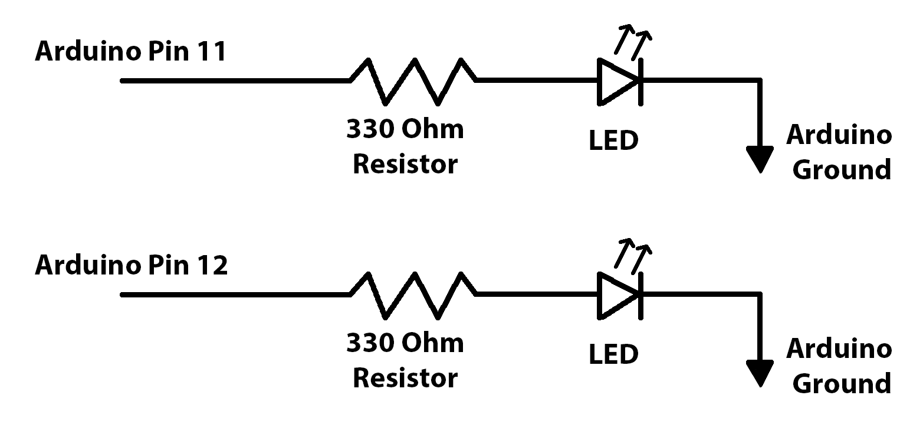
I like to use a Green LED for forward and a red for reverse motion.

